Group Business | CEIS Ayrshire
Job Title | Progression Coordinator (Employability Readiness & Pipeline), Family Forward Ayrshire
Department | Family Forward Ayrshire
Name of Post Holder
Reports to (Job Title) | Programme Manager
Organisation Chart
(showing job in context of Group Business)
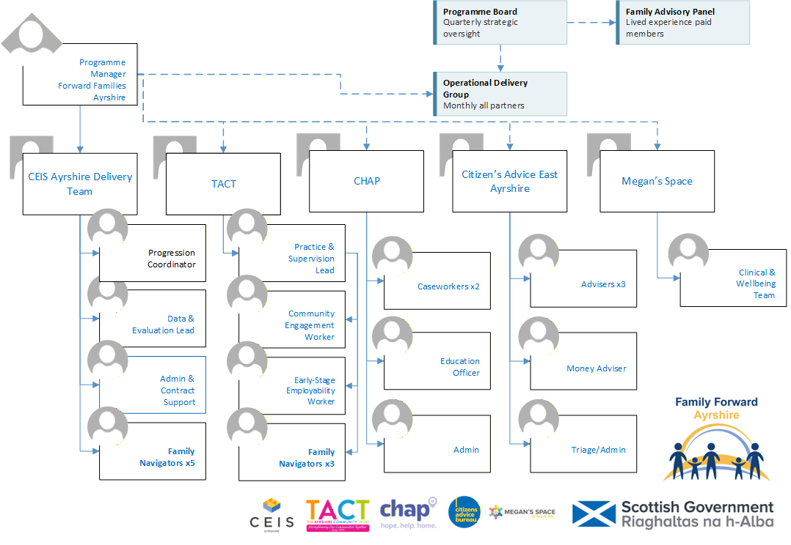

Location
Ayrshire (hybrid working with travel across North, East and South Ayrshire)
Contract
Fixed-term until March 2027 (renewal subject to future funding)
Hours
Full-time
Salary
£29,000 - £32,000 (dependent on experience)
Employer
CEIS Ayrshire

Job Context
(a description of the job in the context of where it fits in the overall structure of the Group Business and beyond if required).
CEIS Ayrshire operates within the social, economic and political environment concerned with the regeneration of disadvantaged communities. As lead organisation of the Family Forward Ayrshire partnership, CEIS Ayrshire is responsible for overall programme management, the funder relationship, and the delivery of CEIS-employed staff within the integrated operating model. Family Forward Ayrshire is a whole-family support programme across North, East and South Ayrshire, funded by the Scottish Government's Whole Family Support Third Sector Delivery Fund. The programme is delivered by a partnership of five organisations — CEIS Ayrshire (lead), TACT, CHAP, Citizens Advice East Ayrshire and Megan's Space — and will reach 431 families, securing £1.275m–£1.5m in direct financial gains and supporting 120–135 parents into work, better-paid work or accredited training. Every intensive family has one named Family Navigator and one co-produced plan; specialists work on shared caseloads inside that plan, not through referral chains. All posts are required to work within the programme's non-negotiable ways of working: shared caseload (specialists join the family's plan rather than receiving referrals); voluntary engagement only; trauma-informed practice; and same-day recording in the shared case management system.
Job Purpose
(a description of what the job entails and why it exists).
To own the progression strand of every family plan that reaches employment-readiness: readiness work built on what the adult actually wants, financial safety through better-off calculations before any change, warm and held handovers into the right pipeline for each area, and an employer base offering work that genuinely fits family life. The target this post carries: 120–135 parents into employment, better-paid work or accredited training, with 65% sustained at six months — one family at a time, at the family's pace.
Assignment and Review of Work
(who the post holder reports to, and who will review their work, how and when this will happen).
The Progression Coordinator reports to the Programme Manager. Work is generated by Navigator referrals into family plans and by employer and pipeline relationship management. The post holder manages their own workload in response to family plan activity across all three Ayrshire areas. Formal supervision is monthly with the Programme Manager; performance is reviewed against the programme's progression and sustainment targets bi-annually.
Key Deliverables
(a numbered list of the major KPIs and KDIs for the job).
- Join family plans personally when Navigators bring you in — a three-way introduction, never a referral; run readiness conversations that start from what the adult wants, not what vacancies exist.
- Coordinate a better-off-in-work calculation with CHAP before any job, hours or training change — a programme rule with no exceptions — and ensure in-work benefit adjustments land in the first weeks of work.
- Build the activity ladder for each adult: confidence work (with TACT's early-stage strand for those furthest back), short courses, accredited training, volunteering with a trajectory, employment.
- Remove progression barriers through the Family Support Fund: fees, equipment, interview and work clothing, bridging childcare and transport.
- Manage every pipeline handover personally: named receiving contact, three-way introduction, continued Navigator involvement, and a 4-week handover check — a handover without a completed check is an open action.
- Develop and brief employers honestly across the three areas: flexible, term-time and family-friendly opportunities; what supporting a returning parent involves; maintain relationships with a named next action.
- Maintain the voluntary-only framing with DWP work coaches and correct any drift toward conditionality in how the programme is presented.
- Support families when jobs fall through or don't work — debrief without judgement, keep what was gained, reset the next step smaller; support leaving a bad job with a plan.
- Maintain accurate records of all progression activity, employer contacts and handover outcomes in the shared case management system.
Responsibility for Resources (direct or indirect)
(both human and other resources, description of other resources (if any).
Number of people: N/A (no direct line management responsibility)
Their Job types: N/A
Budgets: Access to Family Support Fund for progression barriers (fees, equipment, clothing, bridging costs)
Communications and Working Relationships
Internal
- Programme Manager (reports to)
- All eight Family Navigators — main referral and co-working relationship
- Data & Evaluation Lead — recording progression and sustainment outcomes
External
- Adults on family plans reaching employment-readiness (primary client group)
- CHAP — better-off-in-work calculations for every employment change
- Employability pipelines: CEIS Ayrshire North Ayrshire contracted service; East and South Ayrshire council pipelines
- Employers — developing flexible, family-friendly employment opportunities across three areas
- DWP work coaches — voluntary-engagement interface
- TACT Early-Stage Employability Worker — co-working on confidence and readiness strand
- Training providers across Ayrshire
Job Requirements
(qualifications, skills and experience – for job not specific job holder.

 | Essential | Desirable
1 EDUCATION / QUALIFICATIONS
Relevant qualification in employability, careers guidance, community learning or a related field, or equivalent demonstrable experience
2 EXPERIENCES
Experience of employability delivery with people facing significant barriers to work
Demonstrable employer engagement: developing opportunities and briefing employers honestly about supported recruitment
Organised follow-through: handover checks, employer next-actions, in-work support diarised and kept
Experience of in-work support and sustainment models
Existing Ayrshire employer relationships
3 KNOWLEDGE
Working knowledge of benefits-and-work interaction sufficient to frame better-off conversations credibly (calculations are CHAP's)
Knowledge of the Ayrshire employability landscape — NOLB, council pipelines, training providers
4 SKILLS AND ABILITIES
Ability to work inside someone else's relationship: joining a Navigator-held plan without taking it over
Commitment to progression at the family's pace — evidence of resisting target-driven pushing
Full driving licence and access to transport, or equivalent three-area capability
5 PERSONAL
Commitment to person-centred employability practice; no conditionality in any aspect of the role
Able to maintain an honest, transparent working relationship with DWP and employers without creating conditionality for families

Signature of Postholder
Signature of Manager
Job Description Compiled by
BH
Date Completed/Revised
17/08/2026
Job description should be reviewed annually v2 17/08/2026

